RSE C Programming Assignment 1

Kaushik

**QUESTION 1**

1. OBTAIN **float** interest;
2. OBTAIN **int** deposit;
3. **int** depositClone = deposit;
4. **int** endValue = 2*deposit;
5. **int** year = 0;
6. WHILE(depositClone<=endValue)

depositClone = depositClone + depositClone*rate/100;

year++

1. ENDWHILE
2. print (year);

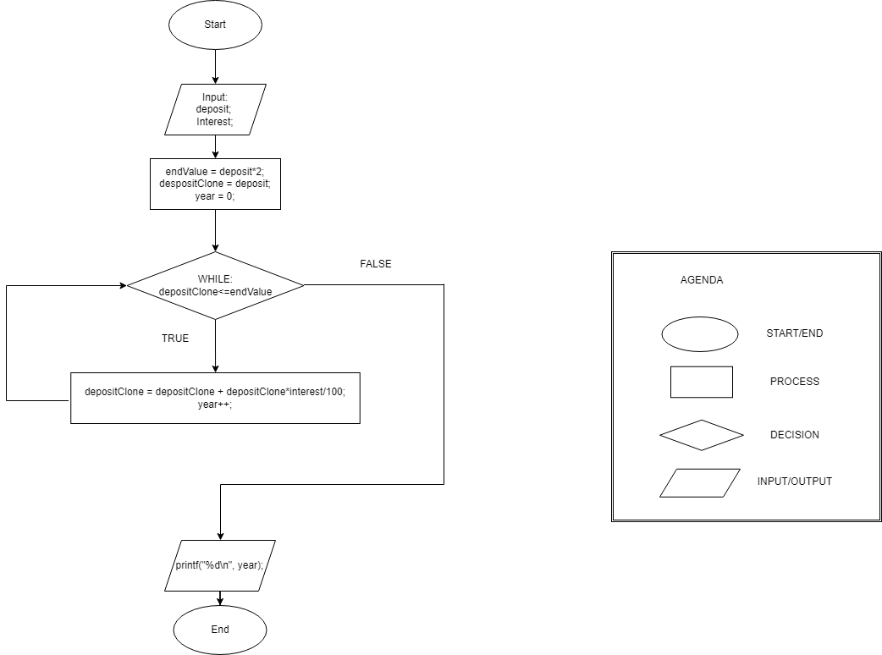

**QUESTION 2**

1. **const** distance = 15000*10;
2. **const** fuelprice = 4;
3. OBTAIN vCostA;
4. OBTAIN mpgA;
5. OBTAIN vCostB;
6. OBTAIN mpgB;
7. **Int** fuelCostA = (distance/mpgA)*fuelprice;
8. **Int** fuelCostB = (distance/mpgB)*fuelprice;
9. **Int** totalCostA = fuelCostA+vCostA;
10. **Int** totalCostB = fuelCostB+vCostB;
11. IF( totalCostB>totalCostA)THEN
12. print("The car that costs %d is better", vCostA);
13. ELSE IF( totalCostA>totalCostB)
14. print("The car that costs %d is better", vCostB);
15. ELSE
16. print(“They are worth the same in the long run);
17. ENDIF

Note: vCost means Vehicle Cost